Chapter 4.1 – Quiz 1 – Power and Decibels

G5B01 - What dB change represents a factor of two increase or decrease in power?

* A. Approximately 2 dB
* B. Approximately 3 dB
* C. Approximately 6 dB
* D. Approximately 9 dB

G5B03 - How many watts of electrical power are consumed if 400 VDC is supplied to an 800-ohm load?

* A. 0.5 watts
* B. 200 watts
* C. 400 watts
* D. 3200 watts

G5B04 - How many watts of electrical power are consumed by a 12 VDC light bulb that draws 0.2 amperes?

* A. 2.4 watts
* B. 24 watts
* C. 6 watts
* D. 60 watts

G5B05 - How many watts are consumed when a current of 7.0 milliamperes flows through a 1,250-ohm resistance?

* A. Approximately 61 milliwatts
* B. Approximately 61 watts
* C. Approximately 11 milliwatts
* D. Approximately 11 watts

G5B10 - What percentage of power loss is equivalent to a loss of 1 dB?

* A. 10.9 percent
* B. 12.2 percent
* C. 20.6 percent
* D. 25.9 percent

End of Quiz 1

Chapter 4.2 – Quiz 2 – AC Power

G5B06 - What is the PEP produced by 200 volts peak-to-peak across a 50-ohm dummy load?

* A. 1.4 watts
* B. 100 watts
* C. 353.5 watts
* D. 400 watts

G5B07 - What value of an AC signal produces the same power dissipation in a resistor as a DC voltage of the same value?

* A. The peak-to-peak value
* B. The peak value
* C. The RMS value
* D. The reciprocal of the RMS value

G5B08 - What is the peak-to-peak voltage of a sine wave with an RMS voltage of 120 volts?

* A. 84.8 volts
* B. 169.7 volts
* C. 240.0 volts
* D. 339.4 volts

G5B09 - What is the RMS voltage of a sine wave with a value of 17 volts peak?

* A. 8.5 volts
* B. 12 volts
* C. 24 volts
* D. 34 volts

G5B11 - What is the ratio of PEP to average power for an unmodulated carrier?

* A. 0.707
* B. 1.00
* C. 1.414
* D. 2.00

G5B12 - What is the RMS voltage across a 50-ohm dummy load dissipating 1200 watts?

* A. 173 volts
* B. 245 volts
* C. 346 volts
* D. 692 volts

G5B13 - What is the output PEP of an unmodulated carrier if the average power is 1060 watts?

* A. 530 watts
* B. 1060 watts
* C. 1500 watts
* D. 2120 watts

G5B14 - What is the output PEP of 500 volts peak-to-peak across a 50-ohm load?

* A. 8.75 watts
* B. 625 watts
* C. 2500 watts
* D. 5000 watts

End of Quiz 2

Chapter 4.3 – Quiz 3 – Basic Components

G7A09 - Which symbol in figure G7-1 represents a field effect transistor?

* A. Symbol 2
* B. Symbol 5
* C. Symbol 1
* D. Symbol 4

G7A10 - Which symbol in figure G7-1 represents a Zener diode?

* A. Symbol 4
* B. Symbol 1
* C. Symbol 11
* D. Symbol 5

G7A11 - Which symbol in figure G7-1 represents an NPN junction transistor?

* A. Symbol 1
* B. Symbol 2
* C. Symbol 7
* D. Symbol 11

G7A12 - Which symbol in Figure G7-1 represents a solid core transformer?

* A. Symbol 4
* B. Symbol 7
* C. Symbol 6
* D. Symbol 1

G7A13 - Which symbol in Figure G7-1 represents a tapped inductor?

* A. Symbol 7
* B. Symbol 11
* C. Symbol 6
* D. Symbol 1

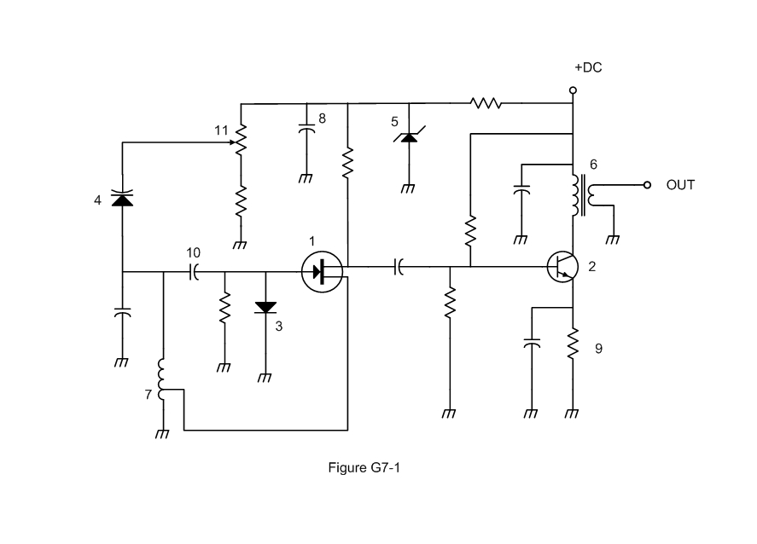

G6B01 - What determines the performance of a ferrite core at different frequencies?

* A. Its conductivity
* B. Its thickness
* C. The composition, or "mix," of materials used
* D. The ratio of outer diameter to inner diameter

G6B05 - What is an advantage of using a ferrite core toroidal inductor?

* A. Large values of inductance may be obtained
* B. The magnetic properties of the core may be optimized for a specific range of frequencies
* C. Most of the magnetic field is contained in the core
* D. All these choices are correct

G6A04 - Which of the following is characteristic of an electrolytic capacitor?

* A. Tight tolerance
* B. Much less leakage than any other type
* C. High capacitance for a given volume
* D. Inexpensive RF capacitor

G6A08 - Which of the following is characteristic of low voltage ceramic capacitors?

* A. Tight tolerance
* B. High stability
* C. High capacitance for given volume
* D. Comparatively low cost

G5C01 - What causes a voltage to appear across the secondary winding of a transformer when an AC voltage source is connected across its primary winding?

* A. Capacitive coupling
* B. Displacement current coupling
* C. Mutual inductance
* D. Mutual capacitance

G5C02 - What is the output voltage if an input signal is applied to the secondary winding of a 4:1 voltage step-down transformer instead of the primary winding?

* A. The input voltage is multiplied by 4
* B. The input voltage is divided by 4
* C. Additional resistance must be added in series with the primary to prevent overload
* D. Additional resistance must be added in parallel with the secondary to prevent overload

G5C05 - Why is the primary winding wire of a voltage step-up transformer usually a larger size than that of the secondary winding?

* A. To improve the coupling between the primary and secondary
* B. To accommodate the higher current of the primary
* C. To prevent parasitic oscillations due to resistive losses in the primary
* D. To ensure that the volume of the primary winding is equal to the volume of the secondary winding

G5C06 - What is the voltage output of a transformer with a 500-turn primary and a 1500-turn secondary when 120 VAC is applied to the primary?

* A. 360 volts
* B. 120 volts
* C. 40 volts
* D. 25.5 volts

G5B02 - How does the total current relate to the individual currents in a circuit of parallel resistors?

* A. It equals the average of the branch currents
* B. It decreases as more parallel branches are added to the circuit
* C. It equals the sum of the currents through each branch
* D. It is the sum of the reciprocal of each individual voltage drop

G5C03 - What is the total resistance of a 10-, a 20-, and a 50-ohm resistor connected in parallel?

* A. 5.9 ohms
* B. 0.17 ohms
* C. 17 ohms
* D. 80 ohms

G5C04 - What is the approximate total resistance of a 100- and a 200-ohm resistor in parallel?

* A. 300 ohms
* B. 150 ohms
* C. 75 ohms
* D. 67 ohms

G5C08 - What is the equivalent capacitance of two 5.0-nanofarad capacitors and one 750-picofarad capacitor connected in parallel?

* A. 576.9 nanofarads
* B. 1,733 picofarads
* C. 3,583 picofarads
* D. 10.750 nanofarads

G5C09 - What is the capacitance of three 100-microfarad capacitors connected in series?

* A. 0.33 microfarads
* B. 3.0 microfarads
* C. 33.3 microfarads
* D. 300 microfarads

G5C10 - What is the inductance of three 10-millihenry inductors connected in parallel?

* A. 0.30 henries
* B. 3.3 henries
* C. 3.3 millihenries
* D. 30 millihenries

G5C11 - What is the inductance of a circuit with a 20-millihenry inductor connected in series with a 50-millihenry inductor?

* A. 7 millihenries
* B. 14.3 millihenries
* C. 70 millihenries
* D. 1,000 millihenries

G5C12 - What is the capacitance of a 20-microfarad capacitor connected in series with a 50-microfarad capacitor?

* A. 0.07 microfarads
* B. 14.3 microfarads
* C. 70 microfarads
* D. 1,000 microfarads

G5C13 - Which of the following components should be added to a capacitor to increase the capacitance?

* A. An inductor in series
* B. An inductor in parallel
* C. A capacitor in parallel
* D. A capacitor in series

G5C14 - Which of the following components should be added to an inductor to increase the inductance?

* A. A capacitor in series
* B. A capacitor in parallel
* C. An inductor in parallel
* D. An inductor in series

End of Quiz 3